What Drives Life Expectancy Around the World?
A Multiple Linear Regression Analysis
Jessica Kotlarek
December 14, 2025
Executive Summary
The goal of this project was to identify country-level factors associated with differences in life expectancy at birth globally. The guiding question was: What drives life expectancy around the world? In the final model, adult literacy rate, environmental performance index (EPI), income group, and continent were found to be significantly associated with life expectancy. Countries in lower income groups tend to have substantially lower life expectancy than high-income countries, with low-income countries experiencing nearly six fewer years of life expectancy on average after controlling for other factors. Higher adult literacy rates, stronger environmental performance, and continent were also found to be significantly associated with life expectancy. Overall, the final model explains approximately 76% of the variation in life expectancy.

Data
The data analyzed in this report consist of country-level variables compiled from several publicly available sources, including World Bank, World Population Review, World Happiness Report, Our World in Data, and the World Health Organization. Life expectancy at birth in 2024 was used as the dependent variable, and 13 candidate predictors encompassing socioeconomic, environmental, health, and governance characteristics were analyzed. The variables were happiness score (calculated using the Cantril Ladder (0-10 scale for best/worst life)), GDP per capita, health expenditure per capita (public and private), adult literacy rate (percent of adults over the age of 15 that can read and write), continent, income group (low-income, lower-middle-income, upper-middle-income, high-income), healthcare professionals per 1,000 people (including doctors, nurses, and midwives), environmental performance index (how well the ecosystem is protected, 0-100 scale, 0 indicating not protected), gini index (inequality index, 0-100 scale, 0 indicating perfect equality), population density, freedom to make life choices (“in this country, are you satisfied or dissatisfied with your freedom to choose what you do with your life?”, 0-10 scale, 0 indicating dissatisfaction), corruption of government (“is corruption widespread throughout the government in this country or not?”, 0-10 scale, 0 indicating no), and CO₂ per capita. 11 of the variables were quantitative and the other two were categorical. For the two categorical variables, continent and income group, Europe and high-income were set as the reference categories.

Each observation represents a single country. Country names were standardized across all data sources to allow consistent merging. When variables were not available for 2024, the most recent year of available data was used. The initial dataset included 196 countries. Countries with extensive missing data were excluded, resulting in a final analytic sample of 186 countries. As a result, the findings apply primarily to non-small countries with relatively well-reported data. For countries with partially missing data, multiple imputation was performed so that these countries could still contribute to the analysis.

Methods
Multiple linear regression was used to evaluate the associations between life expectancy and a set of 13 potential predictors.

Exploratory analyses were conducted to assess linearity and multicollinearity prior to model selection. Box-Tidwell tests were used to identify appropriate transformations. Transformations were applied to six variables, although none of the transformed variables appeared in the final model. After transformation, multiple imputation was repeated to maintain consistency in the analytic dataset. Multicollinearity was assessed using variance inflation factors (VIFs), and variables with excessively high VIF values that were highly correlated with one another were removed prior to model selection.

Stepwise model selection was used to identify the most significant predictors for the model. To validate this, best subset selection was performed to confirm the results. To evaluate whether including individual predictors significantly improved model fit, p-values for the respective individual predictors were assessed, and partial F-tests were used to test multiple predictors together in the model. Competing models were also compared using adjusted R². Interactions were also tested using partial F-tests. Model assumptions were evaluated using diagnostic plots. Normality of residuals was assessed using a Q-Q plot, and constant variance was evaluated using a residuals versus fitted plot. Influential observations were identified using Cook’s Distance.

Sensitivity analyses were conducted to evaluate the robustness of results. These included re-estimating the model after removing an influential country and comparing results from the imputed dataset to a complete-case analysis in which observations with missing values were excluded.

Results
Final Model
The final multiple linear regression model included adult literacy rate, environmental performance index, income group, and continent as statistically significant indicators of life expectancy globally. Table 1 summarizes the estimated effects and statistical significance for each predictor in the final model.

Table 1: Final Multiple Linear Regression Model
Variable | Estimate
Adult Literacy Rate | 0.08 **
Continent, Europe | 0 (ref)
Continent, Africa | -4.00 ***
Continent, Asia | 2.44 *
Continent, North America | -0.93
Continent, South America | -0.22
Continent, Oceania | -4.46 ***
Continent | ***
Income Group, High | 0 (ref)
Income Group, Upper Middle | -2.92 ***
Income Group, Lower Middle | -4.89 ***
Income Group, Low | -5.79 ***
Income Group | ***
EPI | 0.16 **

The final model explains approximately 76% of the variation in life expectancy across countries. Holding other variables constant, adult literacy rate was positively associated with life expectancy: a one percentage-point increase in adult literacy rate is associated with an increase of about 0.08 years in life expectancy; a 10 percentage-point increase corresponds to roughly 0.8 additional years (9.6 months). Environmental performance was also positively associated with life expectancy, with a 10-point increase in EPI corresponding to roughly 1.6 additional years of life expectancy.

Substantial differences in life expectancy were observed across income groups. Compared to high-income countries, upper-middle-income countries had an average life expectancy that was approximately 2.9 years lower, lower-middle-income countries about 4.9 years lower, and low-income countries nearly 5.8 years lower. These differences represent the largest gaps observed in the model.

Life expectancy also differed significantly across continents after adjusting for income, literacy, and EPI. Countries in Africa and Oceania had life expectancy values that were approximately 4 and 4.5 years lower, respectively, than those in European countries, while countries in Asia had life expectancy values that were about 2.4 years higher than those in Europe on average.

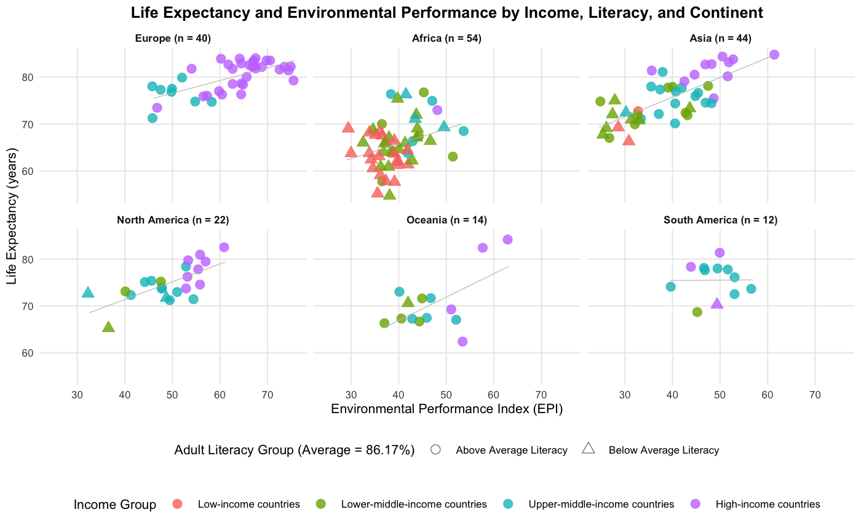
Figure 1: Life Expectancy and Environmental Performance by Income, Literacy, and Continent

Figure 1 reinforces these findings by illustrating how life expectancy rises consistently with EPI, while remaining clearly stratified by income group. Countries with similar EPI scores often have very different life expectancy outcomes, indicating that environmental conditions alone are not sufficient to explain global differences. Clear continental patterns are also visible, with African countries generally appearing at lower life expectancy levels than European countries, consistent with the approximately four-year difference observed in the model. Countries with above-average adult literacy also tend to appear higher in the plot than those with below-average literacy, highlighting the role of education in shaping life expectancy. Adult literacy rate was split into below-average and above-average for plotting purposes.

Diagnostic and Sensitivity Findings
The Q-Q plot suggests that the residuals are approximately normally distributed, and the residuals versus fitted plot indicates that the assumption of constant variance is reasonable. One country, Nauru, was identified as potentially influential based on Cook’s Distance criterion. To assess the impact of this observation, a sensitivity analysis was conducted in which the data were re-imputed after excluding Nauru. Table 2 shows the estimates for both models, the full model, and the model without Nauru. Comparison of the resulting model to the original model showed only minor changes in coefficient estimates, and no changes in sign or significance. The continent Oceania, however, is the most sensitive to the removal of Nauru, but that is to be expected, as Nauru is one of 14 countries in Oceania. Overall, the results of the final model are robust to the influential point.

Table 2: Comparison of coefficient estimates from the original model to those obtained after excluding Nauru.
Variable | Estimate with Nauru | Estimate no Nauru
Adult Literacy Rate | 0.08 ** | 0.08 **
Continent, Europe | 0 (ref) | 0 (ref)
Continent, Africa | -4.00 *** | -3.59 **
Continent, Asia | 2.44 * | 2.69 *
Continent, North America | -0.93 | -0.65
Continent, South America | -0.22 | -0.01
Continent, Oceania | -4.46 *** | -3.19 **
Income Group, High | 0 (ref) | 0 (ref)
Income Group, Upper Middle | -2.92 *** | -3.25 ***
Income Group, Lower Middle | -4.89 *** | -5.34 ***
Income Group, Low | -5.79 *** | -6.22 ***
EPI | 0.16 ** | 0.16 ***

Comparisons between the imputed-data model and a complete-case model were not as simple. Although the complete-case model yielded a slightly higher adjusted R², this improvement comes at the cost of losing nearly half of the data. Because the samples differ so much, the two models are not directly comparable. Consequently, given the loss of information and reduced representativeness, the imputed-data model was retained. Across all sensitivity analyses, the main conclusions remained unchanged.

Appendix
LLM Usage
A large language model (ChatGPT) was used to assist with organizing code, creating functions, debugging errors, and refining written explanations. The model was not used to perform statistical analyses or generate results.

